CHAPTER 1

INTRODUCTION

Introduction
The growing fossil fuel consumption in the road transportation and other commercial sectors has explicit impact on environment,
…….

Problem statement
. …….
.

Scope of research
…….

Research hypothesis
Present research work was carried out in accordance with the following specific research hypothesis
- Natural …….
- The …….

Objectives
This research focuses on the following objectives
- To design…….
- To produce …….
- To analyze…….
- To optimize …….

Organization of the thesis
This thesis is structured in five correlated chapters in following order.
Chapter 1 provides introduction to …….
Chapter 2 discusses state of the art literature review in ……..
Chapter 3 describes…….
Chapter 4 interprets theas obtained results ……..
Chapter 5 concludes the research and presents summary of research findings.

CHAPTER 2

LITERATURE REVIEW

Background
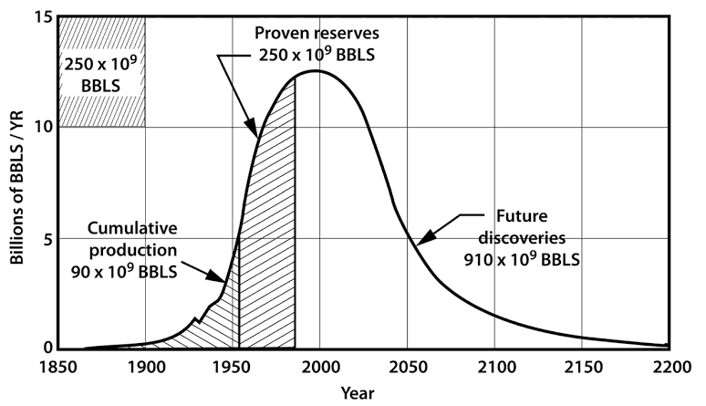
Figure 2.1: Hubbert’s prediction curve for global crude-oil production over1850-2200(Hubbert, 1956).
According to

Table 2.1: Major feedstocks ……..
Feedstock | Country(s) used for biodiesel production
Animal fat | Mexico, Canada, Ireland
Castor | Brazil
Yellow grease | Canada
Source: xxxxx…….

Summary of literature review and research gap
The literature review indicates -------------------

CHAPTER 3

METHODOLOGY

Materials
-------------------.

xxxxxx
-------------------
------------------- research group.

Summary of methodology
-------------------

CHAPTER 4

RESULTS AND DISCUSSION

-----------

--------------
-----

Summary of results and discussion
-------------

CHAPTER 5

CONCLUSION AND RECOMMENDATIONS

Conclusion
- According -------------------
- -------------------

Recommendations
- -------------------
- -------------------.

REFERENCES
[1] Reddy, A. N. R., Saleh, A. A., Islam, M. D. S., &Hamdan, S. (2015). Methanolysis of Crude Jatropha Oil using Heterogeneous Catalyst from the seashells and Eggshells as Green Biodiesel. Asean Journal on Science and Technology for Development, 32(1), 16–30.http://ajstd.org/~ajstd/index.php/ajstd/article/view/9/8
[2] Reddy, A. N. R., Saleh, A. A., Islam,M. S., Hamdan, S., &Maleque, M. A. (2016). Biodiesel Production from Crude Jatropha Oil using a Highly Active Heterogeneous Nanocatalyst by Optimizing Transesterification Reaction Parameters. Energy & Fuels, 30(1), 334–343. https://doi.org/10.1021/acs.energyfuels.5b01899
[3] Reddy, A. N. R., Saleh, A. A., Islam, M. S., &Hamdan, S. (2017). Active Razor Shell CaO Catalyst Synthesis for Jatropha Methyl Ester Production via Optimized Two-Step Transesterification. Journal of Chemistry, 2017(1), 20. https://doi.org/10.1155/2017/1489218
[4] Reddy, A. N. R., Saleh, A. A., Islam, S., &Hamdan, S. (2017). Optimization of Transesterification Parameters for Optimal Biodiesel Yield from Crude Jatropha Oil Using a Newly Synthesized Seashell Catalyst. Journal of Engineering Science and Technology, 12(10), 10.
[5] Reddy, A. N. R., Saleh, A. A., Islam, S., Hamdan,S., Rahman, M. R.,&Masjuki, H. H.,(2018). Experimental evaluation of fatty acid composition influence on Jatropha biodiesel physicochemical properties.Journal of Renewable and Sustainable Energy, 10(1), 20. http://aip.scitation.org/doi/full/10.1063/1.5018743

APPENDICES

Appendix A: Data (if any)

Appendix B: Publications (if any)
[1] Reddy, A. N. R., Saleh, A. A., Islam, M. D. S., &Hamdan, S. (2015). Methanolysis of Crude Jatropha Oil using Heterogeneous Catalyst from the seashells and Eggshells as Green Biodiesel. Asean Journal on Science and Technology for Development, 32(1), 16–30.http://ajstd.org/~ajstd/index.php/ajstd/article/view/9/8
[2] Reddy, A. N. R., Saleh, A. A., Islam,M. S., Hamdan, S., &Maleque, M. A. (2016). Biodiesel Production from Crude Jatropha Oil using a Highly Active Heterogeneous Nanocatalyst by Optimizing Transesterification Reaction Parameters. Energy & Fuels, 30(1), 334–343. https://doi.org/10.1021/acs.energyfuels.5b01899
[3] Reddy, A. N. R., Saleh, A. A., Islam, M. S., &Hamdan, S. (2017). Active Razor Shell CaO Catalyst Synthesis for Jatropha Methyl Ester Production via Optimized Two-Step Transesterification. Journal of Chemistry, 2017(1), 20. https://doi.org/10.1155/2017/1489218
[4] Reddy, A. N. R., Saleh, A. A., Islam, S., &Hamdan, S. (2017). Optimization of Transesterification Parameters for Optimal Biodiesel Yield from Crude Jatropha Oil Using a Newly Synthesized Seashell Catalyst. Journal of Engineering Science and Technology, 12(10), 10.
[5] Reddy, A. N. R., Saleh, A. A., Islam, S., Hamdan,S., Rahman, M. R.,&Masjuki, H. H.,(2018). Experimental evaluation of fatty acid composition influence on Jatropha biodiesel physicochemical properties.Journal of Renewable and Sustainable Energy, 10(1), 20. http://aip.scitation.org/doi/full/10.1063/1.5018743

